Lesson 118
Adding Github Collaborators
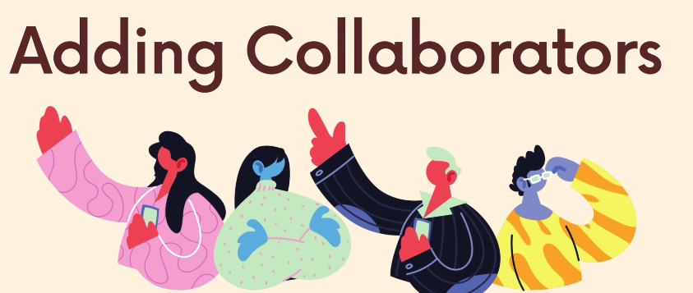
Allowing collaborators will ensure you’re able to push repo into the public.
People need collaboration previleges
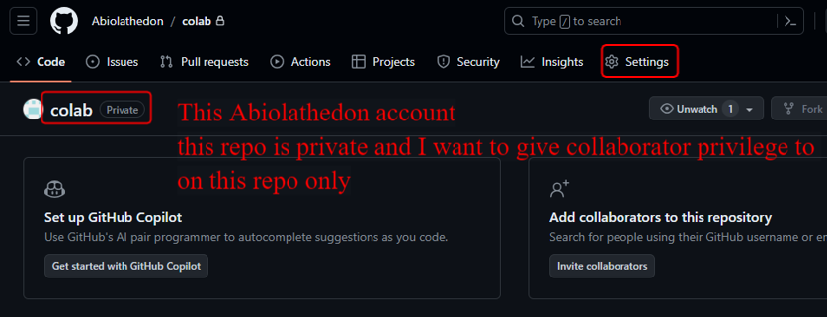
For example this account is private
Click settings
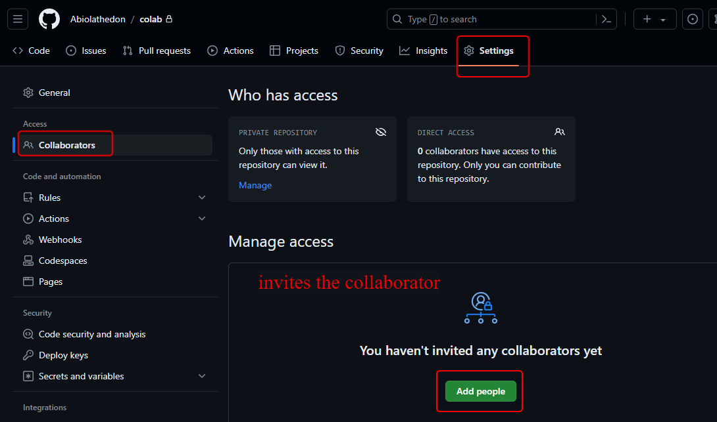
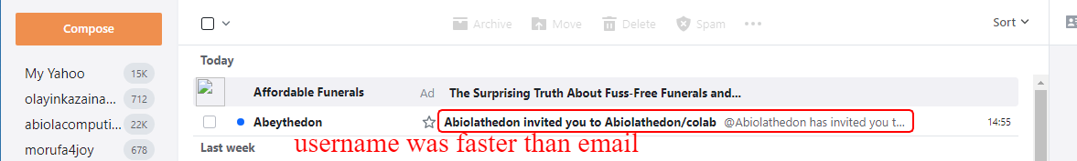
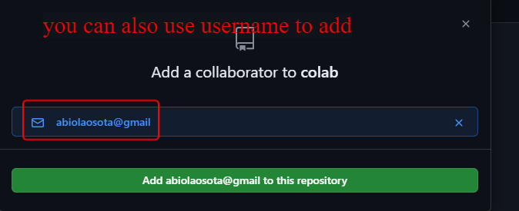
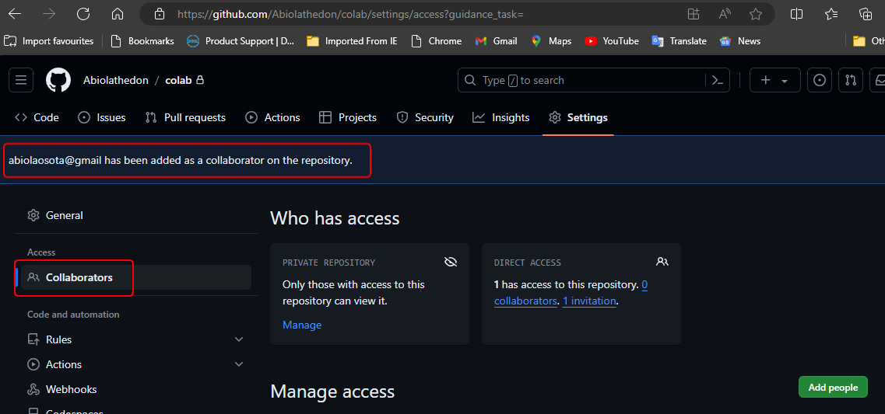
Now I need to go to my email and accept this inivitation is better to use username as its faster
abiolaosota@gmail.com
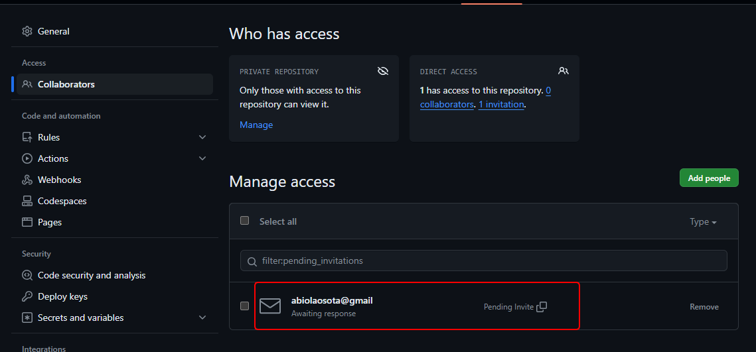
Still waiting I cancelled and used username
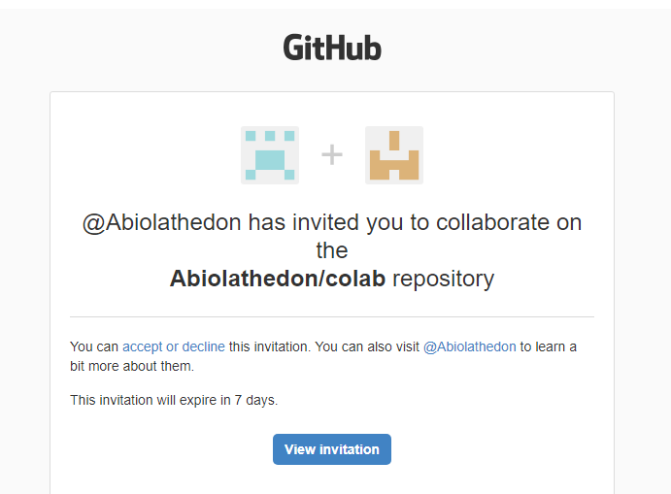
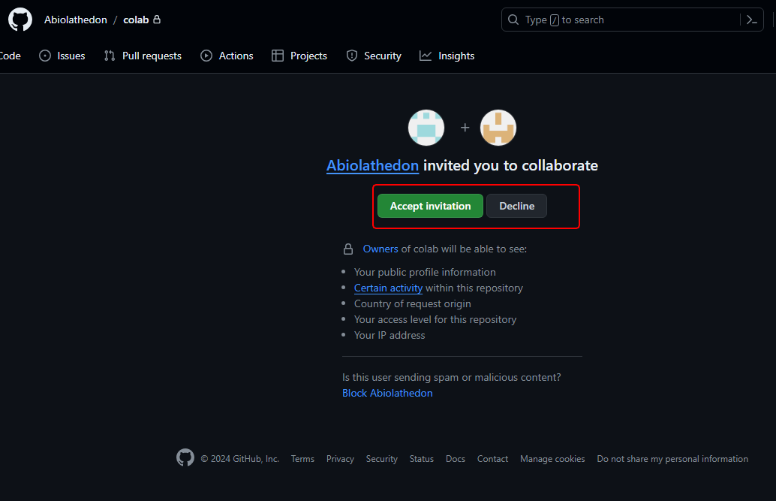
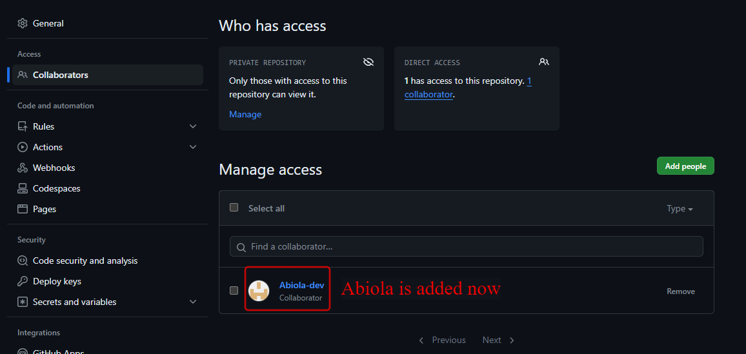
Once you’re collaborators you don’t see access to settings of that repo

Ramadan Monday 01/04/2024
Lesson 119
Github collaboration Demo
Now I want to pretend to be 2 users
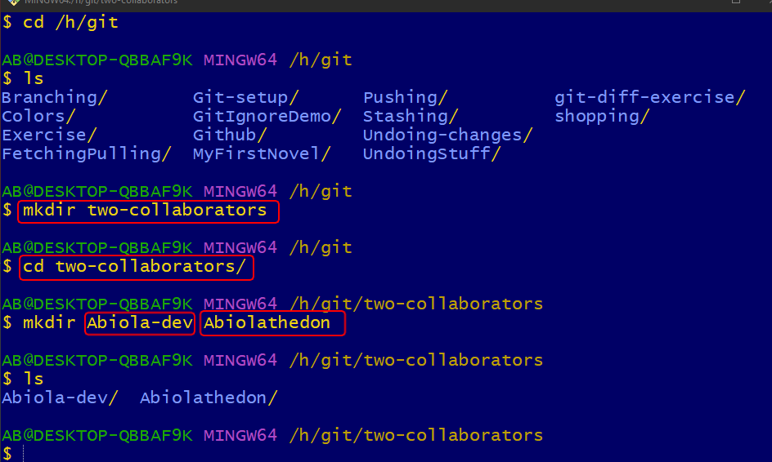
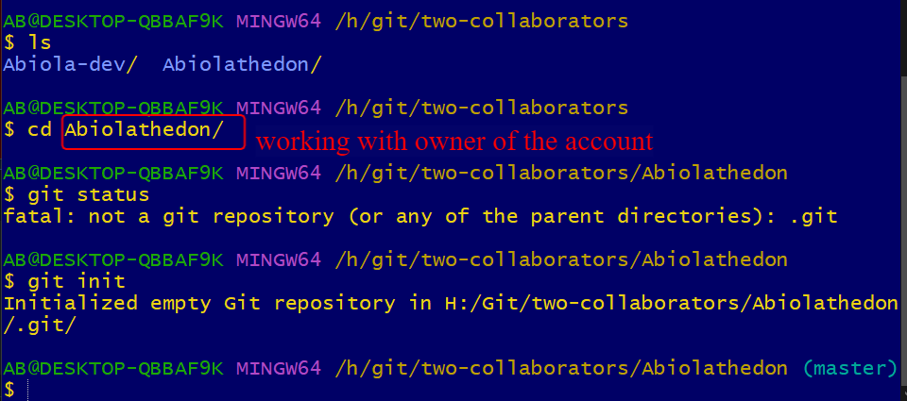
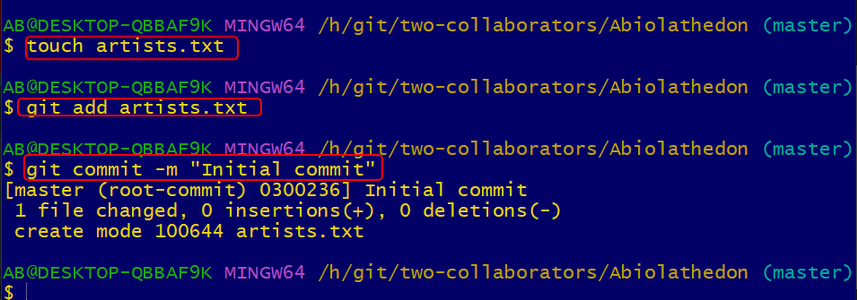
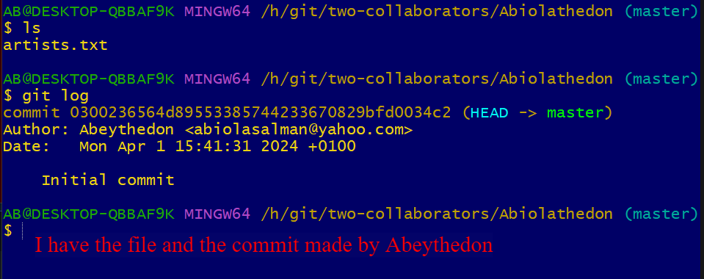
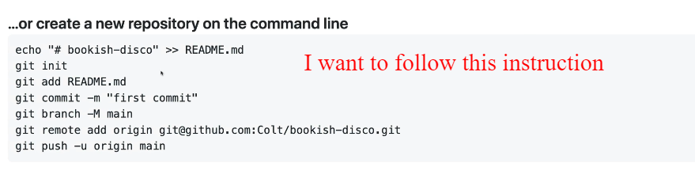
Tuesday Ramadan 02/04/2024
I want to rename my master branch
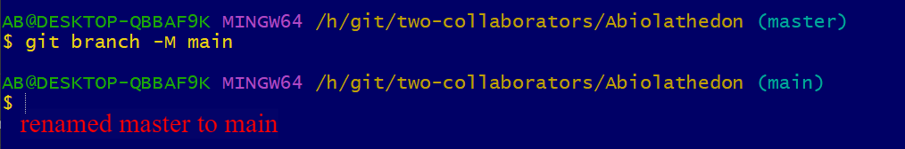
Before I can push I need to add remote to it
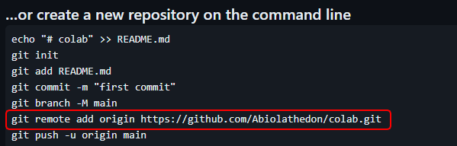
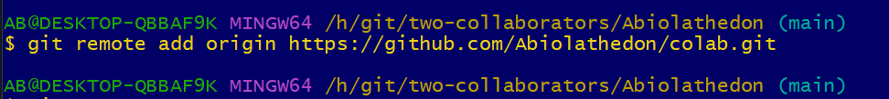
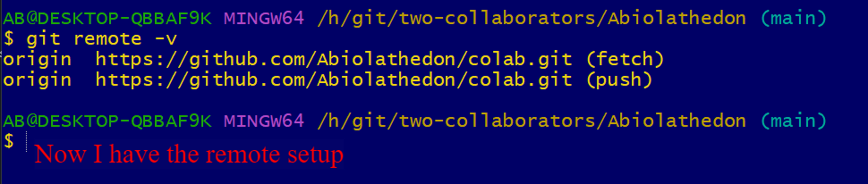
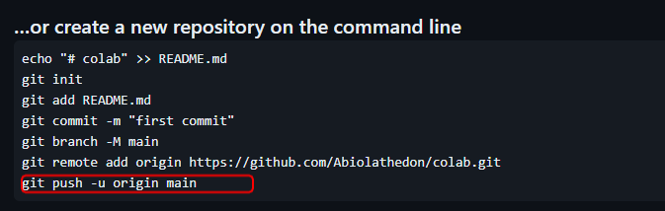
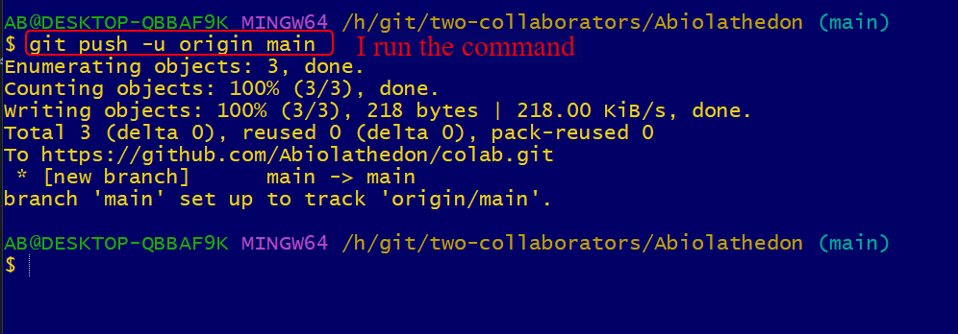
I will check the github repo now.
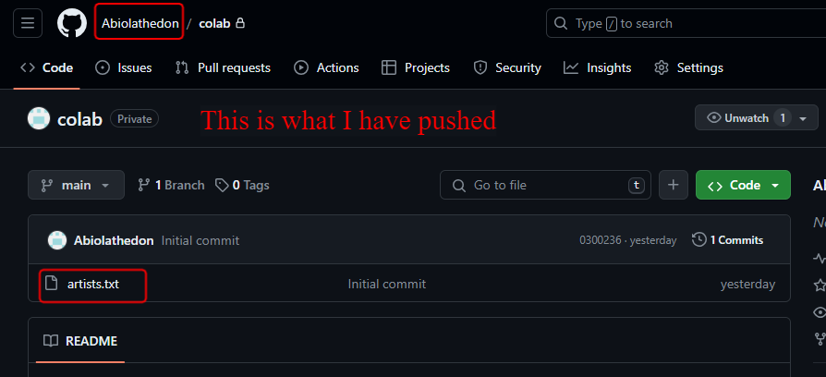
This is on the main branch
I will go back to Abiola-dev account to see
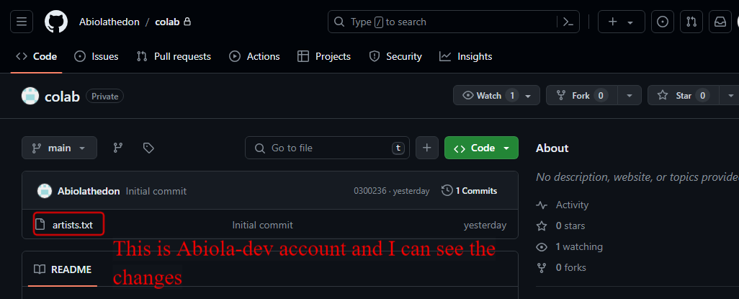
Abiola-dev want to get this on my machine and start working on it. I need to clone it to my machine.
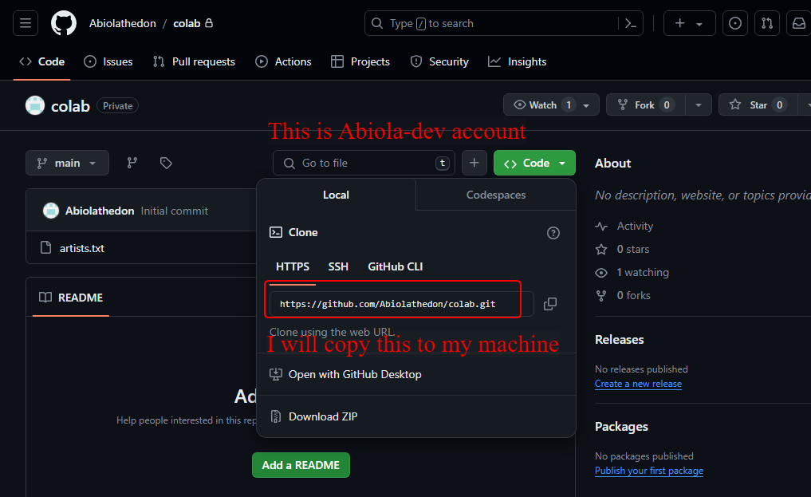
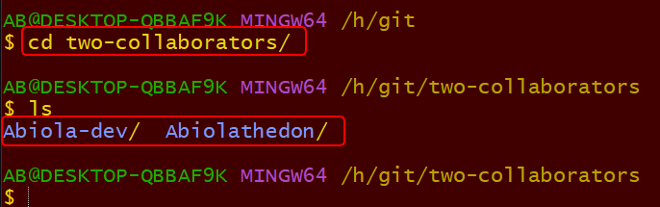
I will switch into Abiola-dev here the 2nd collaborator
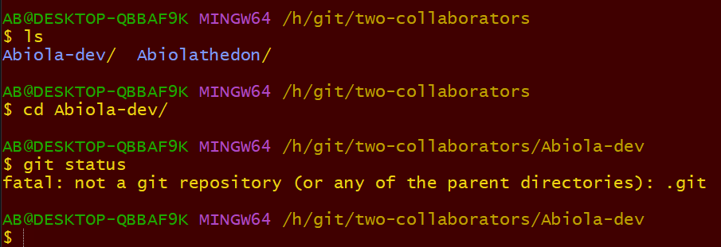
Remember you don’t run git init here because you’re cloning
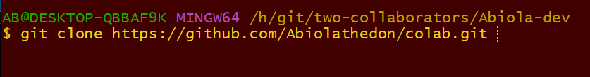
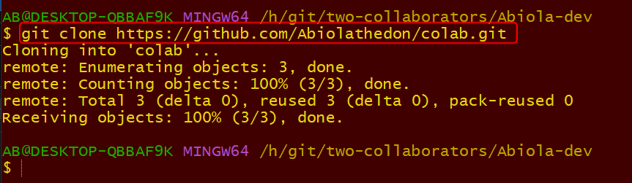
The repo is cloned now.
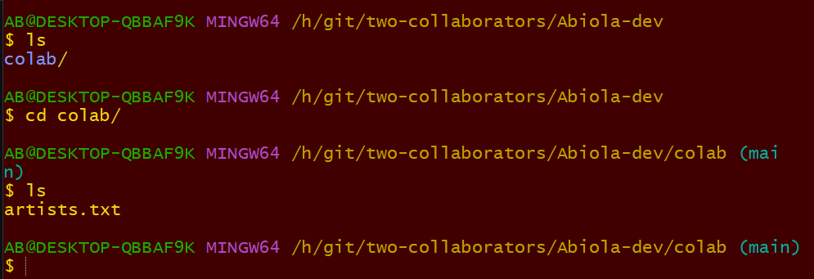
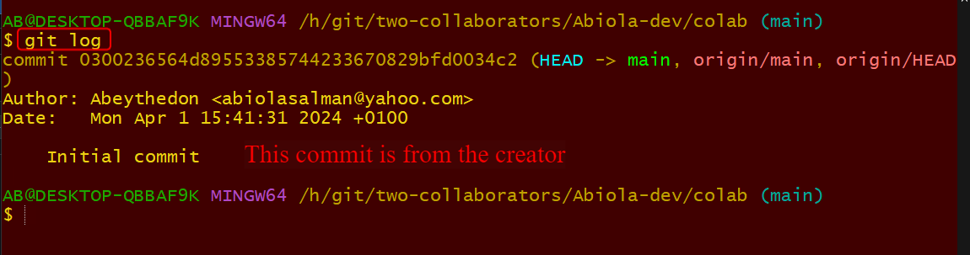
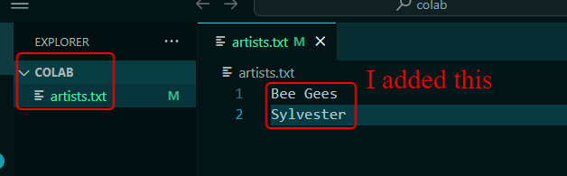

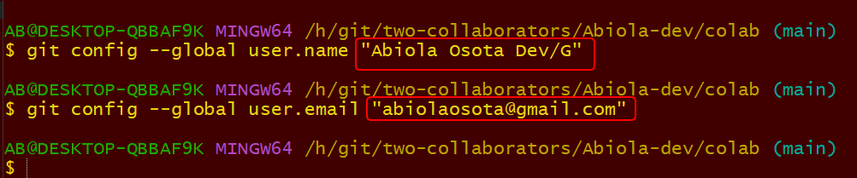
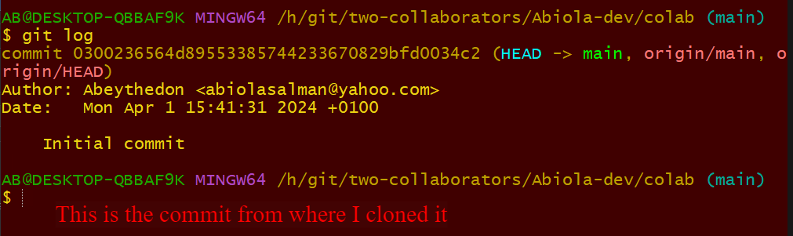
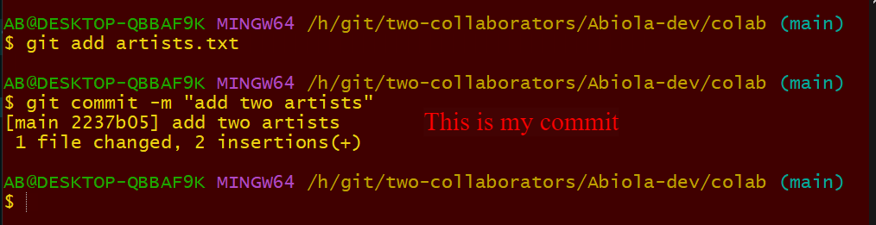
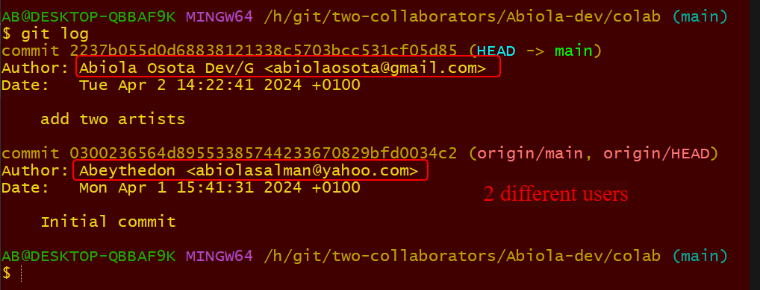
Now I want to push to git hub now
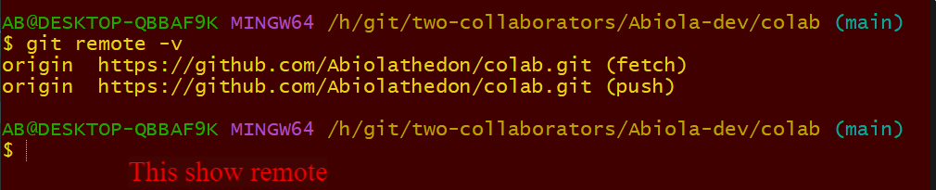
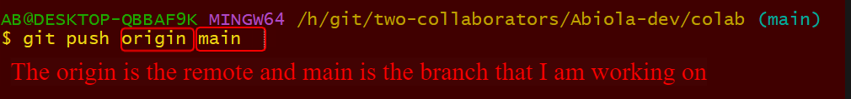
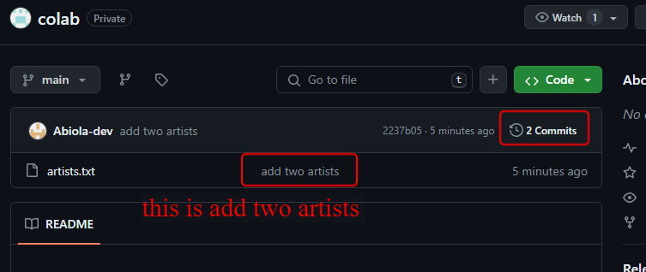
This is Abiola-dev
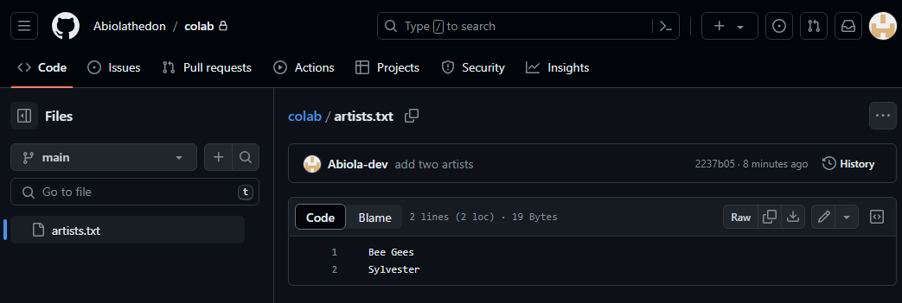
This you can see.
Now how do the Abeythedon get this changes?
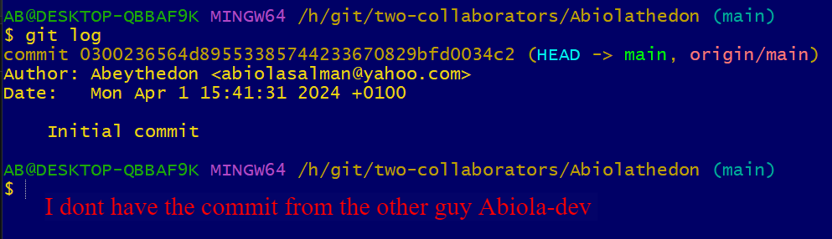
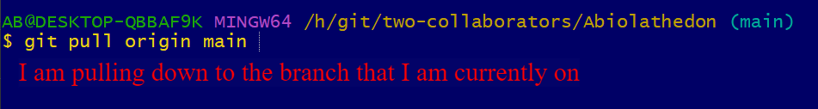
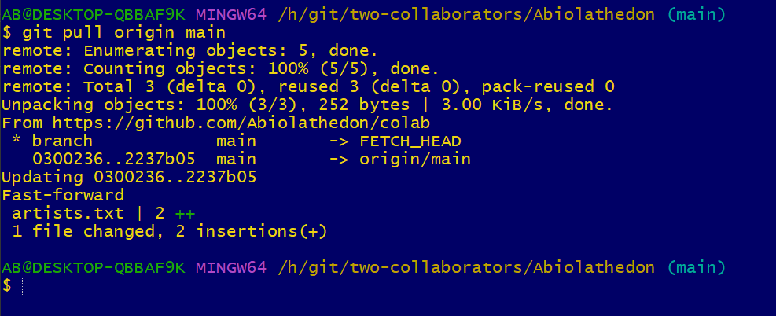
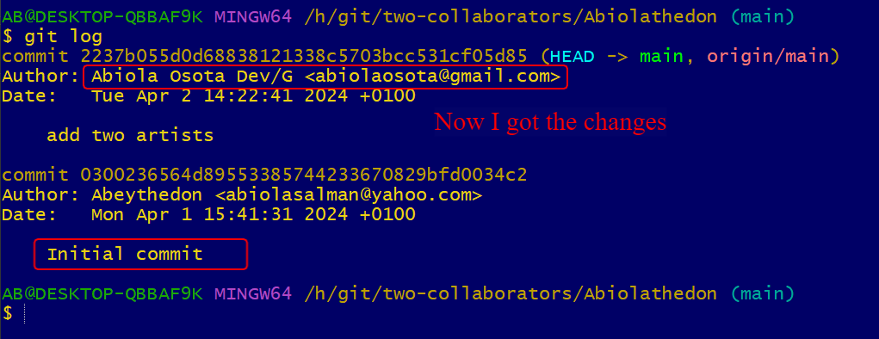
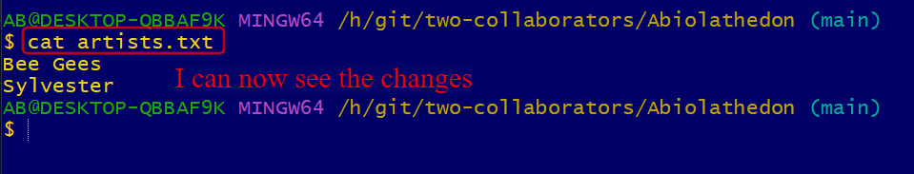
Second Example

Ramadan Monday 01/04/2024

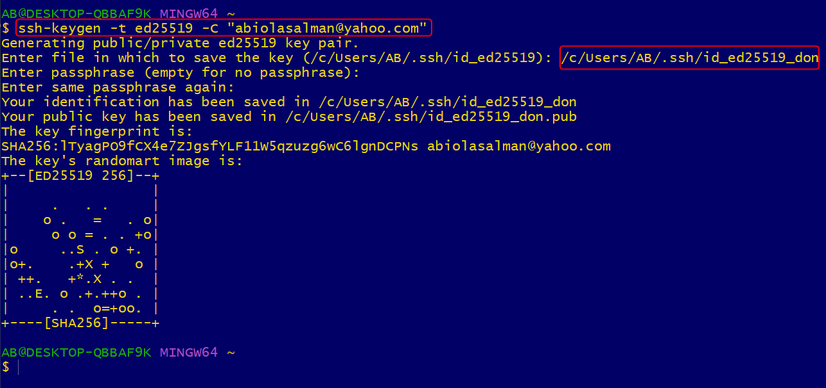
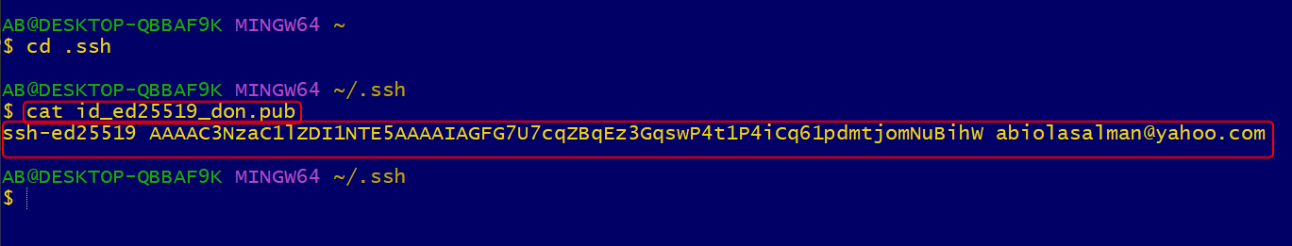
You can also use this command to copy the above code clip < ~/.ssh/id_don.pub
This is the don.pub ssh public key
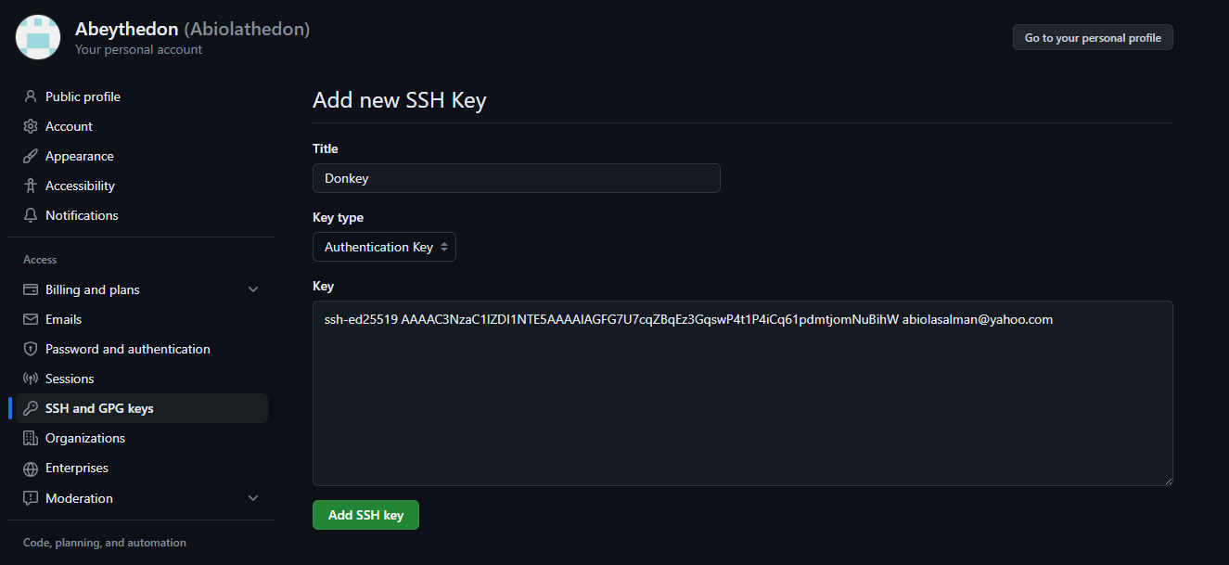

Another Key below is for the Gmail
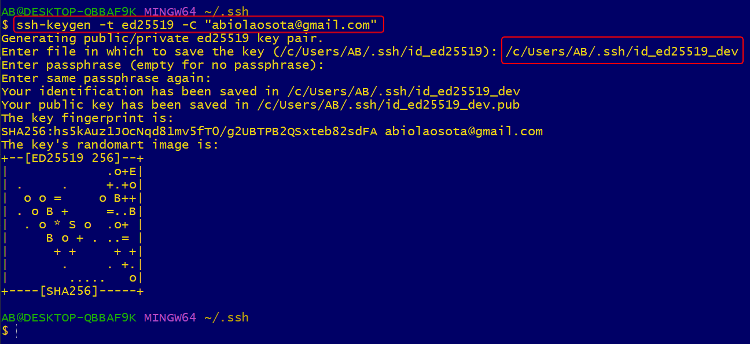
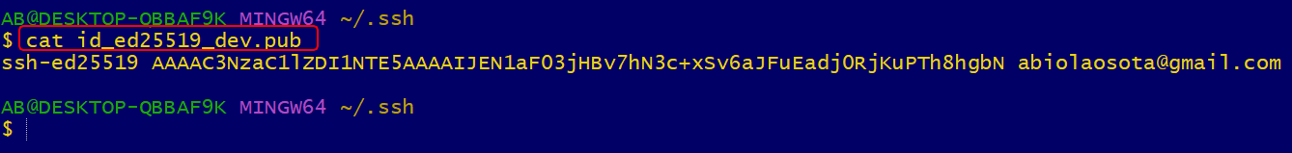
I copied this ssh code and added to Abiola-dev in github
You can also use this command to copy the above code clip < ~/.ssh/id_dev.pub
This is the dev.pub ssh public key. Below are the keys
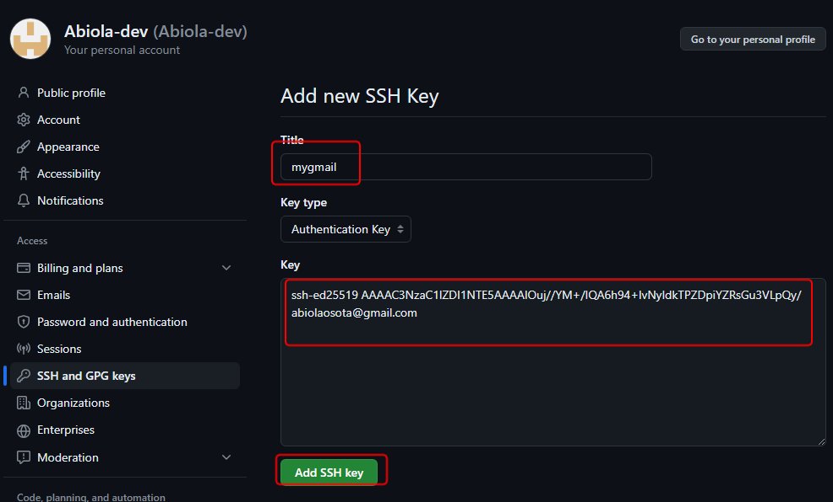
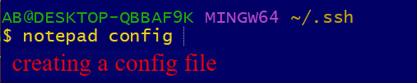
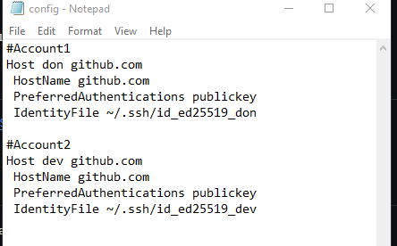
This is configuration file that let you choose btw the 2 accounts

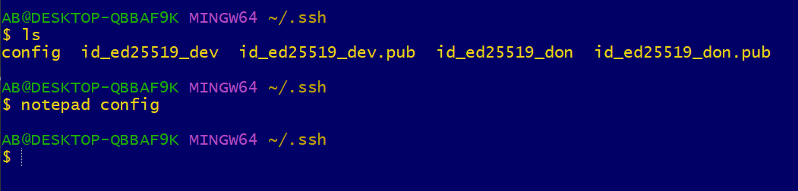
I can see the configuration file above

I don’t think the below is very important
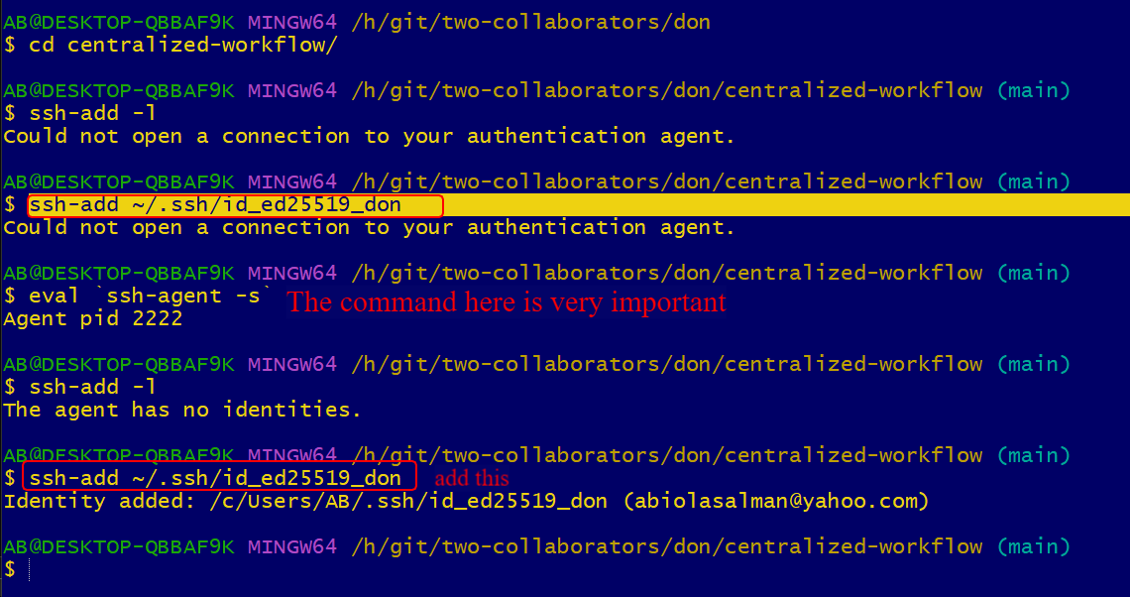
I don’t think the below is important
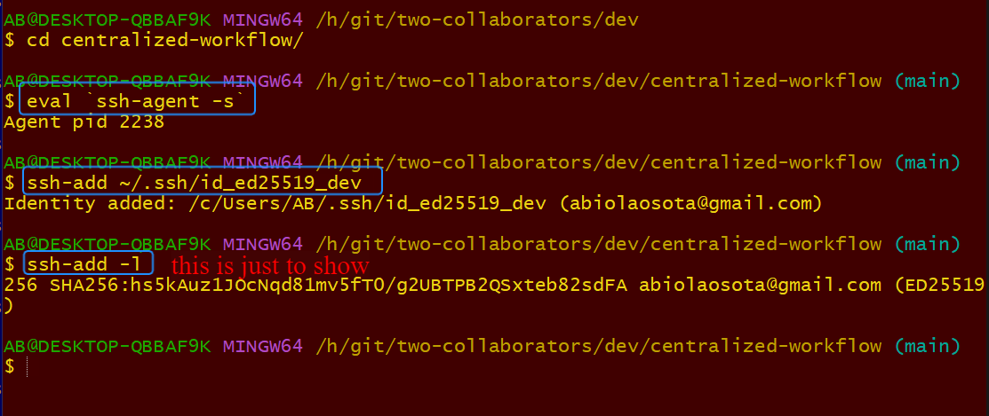
I don’t think the above is important
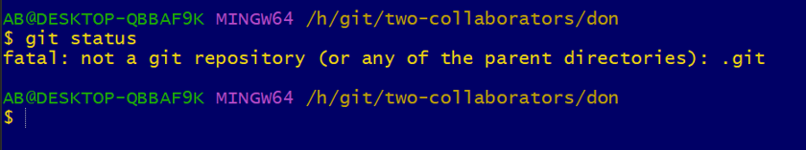
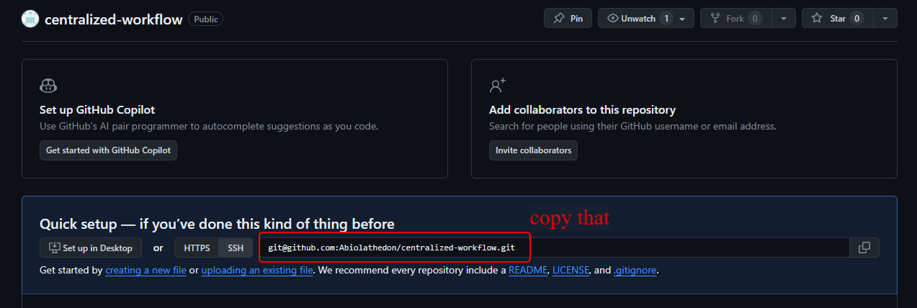

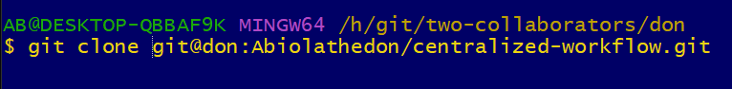
I used don to clone as username
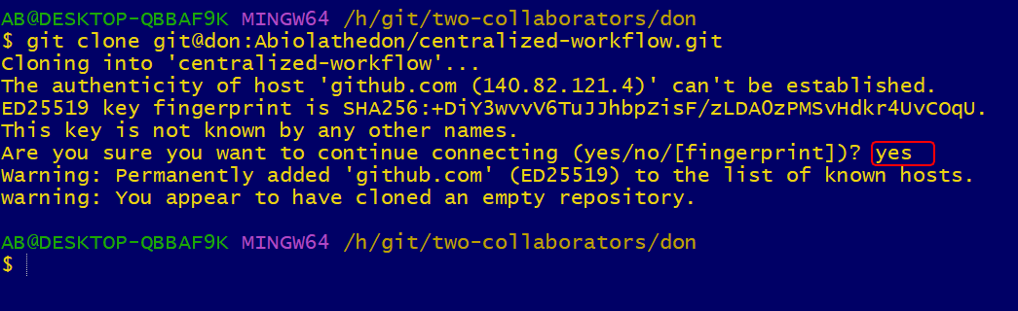
This is the 2nd account below dev
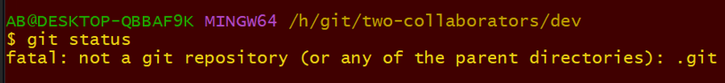
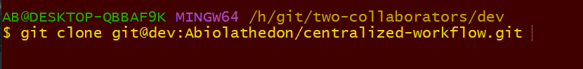
I used the username dev . The clone link is coming from git hub

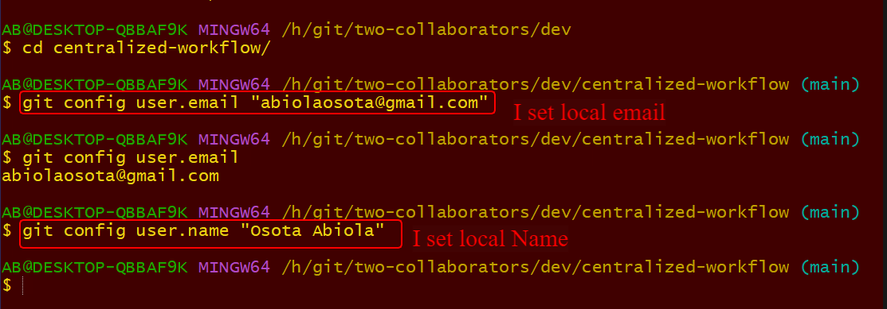
Go inside the directory that you want to use and confirgure local email and username.

